These are the detailed instructions complete with a bit of commentary about how to use SONAR in Eclipse to perform code analysis. These are the steps I had to go through. Yours may vary given you may not hit the wrong items like I did.

Since there is a lot more information than you need, I'm going to try to highlight in **this font** the steps you need to perform and leave the rest as commentary in another font.

To use SONAR in CTI,

1. send in the onboarding application (completed, received confirmation 5/5/2014)
   1. they sent back an email with Application User Credentials, Application Groups, Server Details with a few secret files. Hopefully I'll figure out the next steps from there.
2. Next, I searched all over the SRE Code Analysis pages to see how to use the information that the email gave. Found nothing. So I went to the SonarQube web site and decided to set up the Eclipse plugin to see if I could get something working.

The following steps are referenced at <http://docs.codehaus.org/display/SONAR/SonarQube+in+Eclipse>

**In Eclipse, go to Help->Eclipse Market Place and look for SonarLint.**

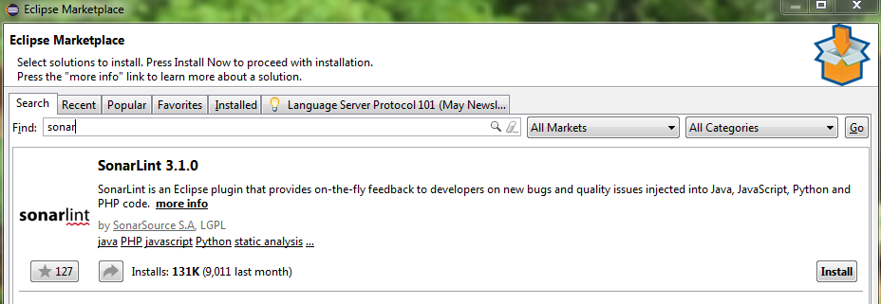

**Click on Install**.

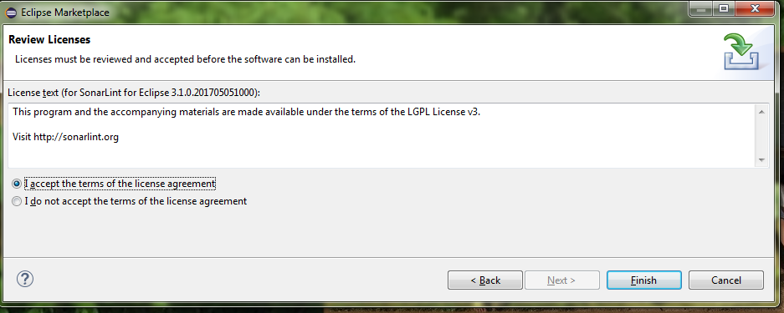

**Accept the license agreement** saying you accept the GNU license and then **click Finish**.

Then it asked me to **restart Eclipse** which I did.

**If you want to change things (I didn't):**

**Go to Window->Preferences and find and expand the SonarLint configurations**



There are some views associated with SonarLint. If you **click the Windows menu item and then Show View, then Other...**, you will see a SonarLint set of views:

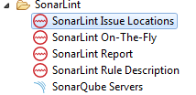

The last gave a link to connect to a SonarQube server

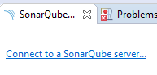

We do have a SonarQube server so we will look at that.

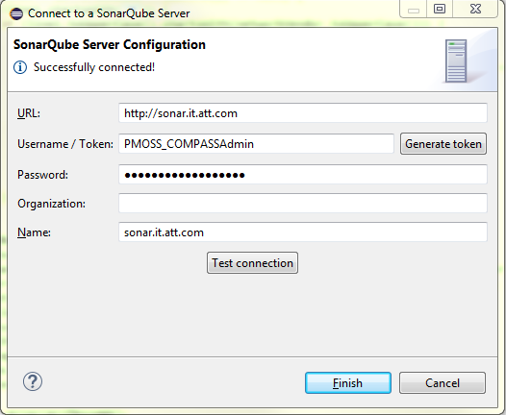

The Username and password are the same. After entering the data as above, hit the Test connection button to make sure you entered the items correctly.

**Click Finish**

It went into a period of Updating data. Not sure what it is updating, but it took a while. Perhaps the slowness was because I was working at home and I have a very slow network connection.



On the SonarLint Report view, there was a button that said:



I clicked that and got a list of items needing looked at:

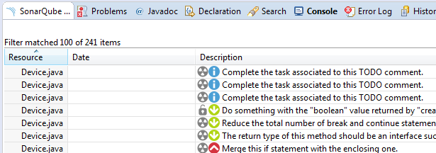

Also, when I switched to the DtvRef project, I saw several items in the SonarLint On-The-Fly view. The On-The-Fly view works when you open a file.

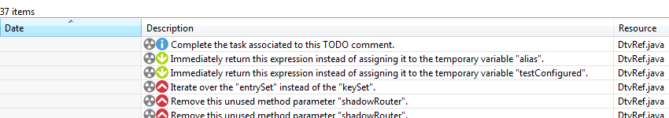

Clicking on any of the items will show the actual code in question. You may have to double-click the item to bring it into view.

Let the fun begin!